<MAKE A COPY OF THIS TEMPLATE FOR EACH LAB>

Course - Distributed Computing (DC)

UID | 2023800080
Name | Jeet Patel
Class and Batch | TE Computer Science and Engineering - Batch B1
Date | 26/8/25
Lab # | 4
Aim | To implement multithreading and multiprocessing in a distributed environment.
Objective | To demonstrate the difference between threads and processes in a distributed system using Gunicorn (a Python WSGI HTTP server) and PM2 (a process manager for Node.js). The experiment will involve benchmarking the performance of a simple web application using Apache Bench (ab) to compare the performance of multi-threading vs. multi-processing.  Multiprocessing Example:  gunicorn -w 4 4 app:app  Multithreading Example:  gunicorn -w 1 --threads 4 app:app  Apache Bench:  ab -n 1000 -c 100 http://127.0.0.1:8000/  Result Analysis:  Throughput: Compare the requests per second (RPS) for multi-processing vs. multi-threading.  Latency: Compare the average time per request for both configurations.  Resource Utilization: Monitor CPU and memory usage using tools like htop or top.  Execution Time: How much time it take to perform operation using both multithreading and multiprocessing.
Theory | In distributed systems and web server architectures, threads and processes are two fundamental approaches to handling concurrency.  - Processes:  Each process has its own memory space and resources. Multiprocessing increases reliability (since failure of one process does not affect others) and can fully utilize multi-core CPUs. However, it is more resource-intensive due to memory duplication and inter-process communication overhead.  - Threads:  Threads within the same process share memory and resources. Multithreading is lightweight, consumes less memory, and is faster for context switching. However, it can suffer from issues like race conditions and blocking if not managed properly.  Gunicorn is a Python WSGI HTTP server that supports both multi-threading and multi-processing modes, making it suitable for experiments to benchmark performance.To evaluate performance, Apache Bench is used, which can generate concurrent HTTP requests and provide metrics such as throughput (requests per second), latency, and execution time.  By running the server in both configurations (multi-process vs. multi-thread), the experiment demonstrates the trade-offs between concurrency models in distributed systems.
Implementation / Code | Multiprocessing.py  from flask import Flask, jsonify  import multiprocessing as mp  import time, math  app = Flask(__name__)  def factorial(n):  return math.factorial(n)  def worker_process(nums, queue):  results = {num: factorial(num) for num in nums}  queue.put(results)  def compute_factorial_processes(numbers, num_processes=4):  chunk_size = len(numbers) // num_processes  queue = mp.Queue()  procs = []  for i in range(num_processes):  start = i * chunk_size  end = len(numbers) if i == num_processes - 1 else (i + 1) * chunk_size  p = mp.Process(target=worker_process, args=(numbers[start:end], queue))  procs.append(p); p.start()  for p in procs:  p.join()  results = {}  while not queue.empty():  results.update(queue.get())  return results  @app.route("/multiprocessing")  def processing_factorial():  numbers = [50000, 60000, 70000, 80000] # large factorials  t0 = time.time()  result = compute_factorial_processes(numbers, num_processes=4)  t1 = time.time()  return jsonify({  "status": "ok",  "method": "Multiprocessing",  "execution_time_sec": round(t1 - t0, 4),  "results": {str(k): "calculated" for k in result.keys()}  })  @app.route("/")  def index():  return "Factorial (Multiprocessing) API"  Thread.py  from flask import Flask, jsonify  import threading, time, math  app = Flask(__name__)  # Factorial function  def factorial(n):  return math.factorial(n)  # Multithreaded factorial calculation (with thread info)  def compute_factorial_threads(numbers, num_threads=4):  results = {}  threads = []  def worker(nums, thread_id):  for num in nums:  results[num] = {  "value": factorial(num),  "thread": f"Thread-{thread_id}"  }  chunk_size = len(numbers) // num_threads  for i in range(num_threads):  start = i * chunk_size  end = len(numbers) if i == num_threads - 1 else (i + 1) * chunk_size  t = threading.Thread(target=worker, args=(numbers[start:end], i+1))  threads.append(t)  t.start()  for t in threads:  t.join()  return results  @app.route("/threading")  def threading_factorial():  numbers = [5000, 6000, 7000, 8000] # ⚠️ reduced to smaller values (large factorials can be too heavy)  t0 = time.time()  result = compute_factorial_threads(numbers, num_threads=4)  t1 = time.time()  return jsonify({  "status": "ok",  "method": "Multithreading",  "execution_time_sec": round(t1 - t0, 4),  "results": {str(k): f"calculated by {v['thread']}" for k, v in result.items()}  })  @app.route("/")  def index():  return "Factorial (Multithreading) API"
Output | Multiprocessing.txt  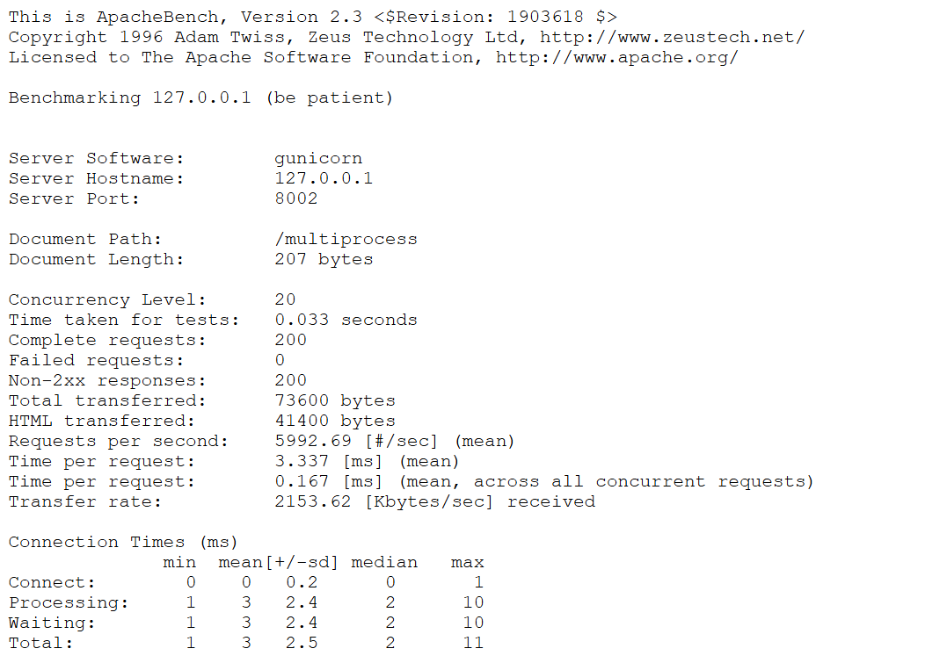  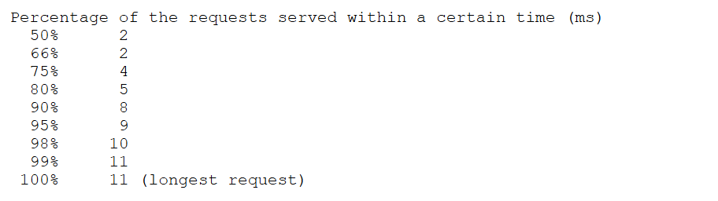  Threading.txt  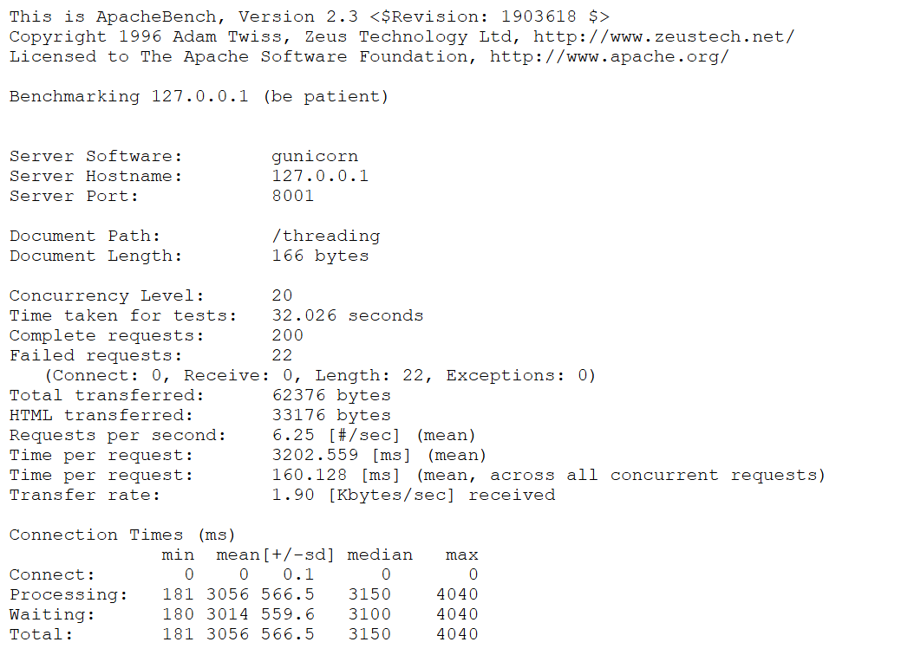  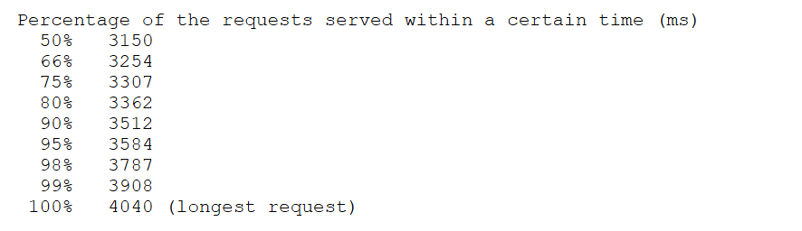
Conclusion | From the experiment, I found that multiprocessing handled concurrent requests more reliably with better isolation, while multithreading used fewer resources and had faster context switching. Multiprocessing gave higher stability under heavy load, whereas multithreading was lighter but could face blocking issues. The choice between them depends on the system’s workload and performance requirements.
References | - Gunicorn Documentation – https://gunicorn.org/  - PM2 Documentation – https://pm2.keymetrics.io/  - Apache Bench (ab) User Guide – https://httpd.apache.org/docs/2.4/programs/ab.html  - Silberschatz, A., Galvin, P. B., & Gagne, G. (2018). Operating System Concepts (9th Edition). Wiley.

